Painting features of the Renaissance
Painting features of the Renaissance | Difficulty
Painting features of the Renaissance | 2

Name︰_______________ （ ） Class︰__________

Historical skill | Interpretating paintings
Related Textbook Content | 2A pp.4, 12

Study the source below and fill in the graph.

Source A An Italian painting in the 1530s, entitled The Music Lesson.
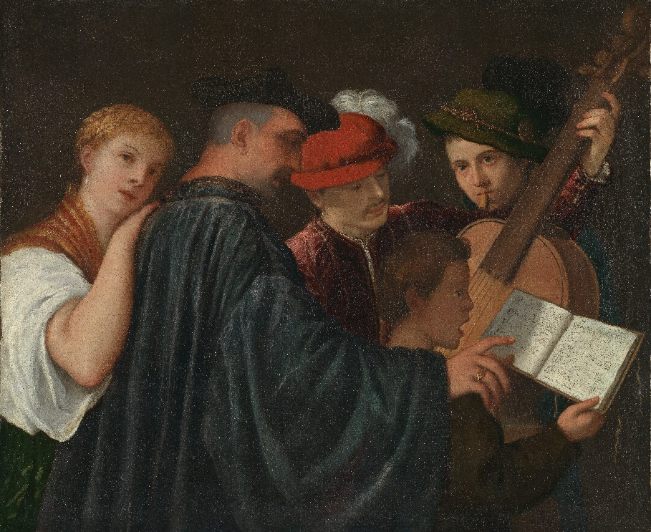

1) Underline the mistakes of the statements below and correct them in the boxes provided.
Tips: Pay attention to publishing year and location, and the figures and objects in the painting.

Correct answer
1. The painting was painted in the 16th century.
2. The painter was from Britain.
3. The theme of the painting focused on religion.
4. The colours used in the painting were dull.
5. Figures in the painting were holding food.
6. When the painting was published, investigating in ancient Egypt civilisation was popular in Europe.

Answers
1)
 | Correct answer
1. The painting was painted in the 16th century. | 16th century
2. The painter was from Britain. | Italy
3. The theme of the painting focused on religion. | human
4. The colours used in the painting were dull. | rich
5. Figures in the painting were holding food. | musical scripts/musical instruments
6. When the painting was published, investigating in ancient Egypt civilisation was popular in Europe. | ancient Greek/ancient Roman

